Q2-1.1. Paste the screenshot of the created topology
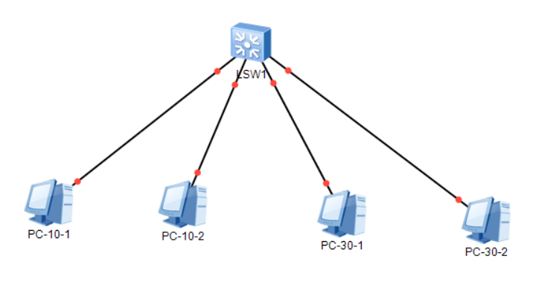
Q2-1.2.DrawIEEE802.1Dtaggedframeformat.
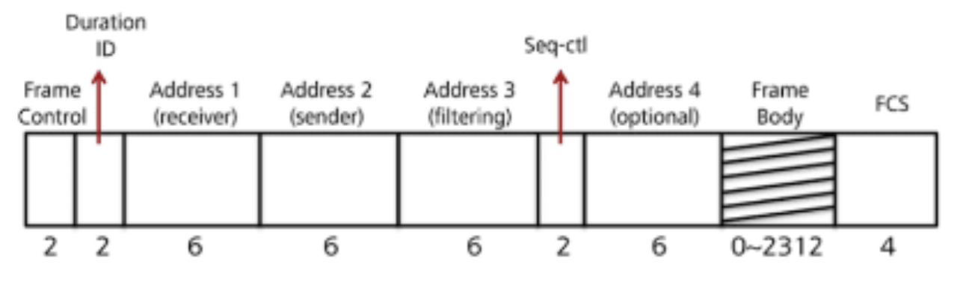
Q2-1.3. Paste the screenshot of VLAN 10 information.
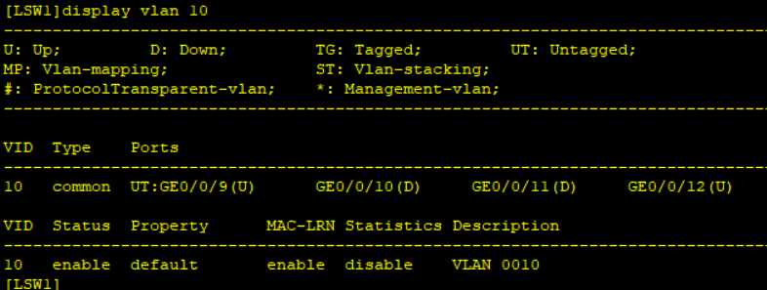

Q2-1.4. Paste the screenshot of VLAN 30 information
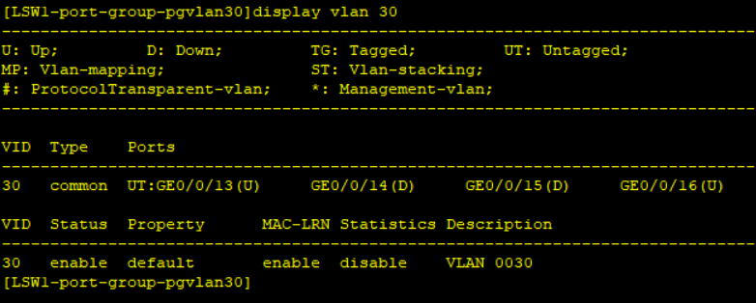

Q2-1.5.SupposeyouaregoingtocreateanewVLAN40,andaddports17-20tothis
VLANinbatches.Pleaselisttheconfigurationcommand：
Vlan40
Port-grouppgvlan40
Group-membergigabitethernet0/0/17togigabitethernet0/0/20
Portlink-typeaccess
Portdefaultvlan40

Q2-1.6. Can PCs in the same VLAN ping each other? Please paste the screenshot of the ping result.
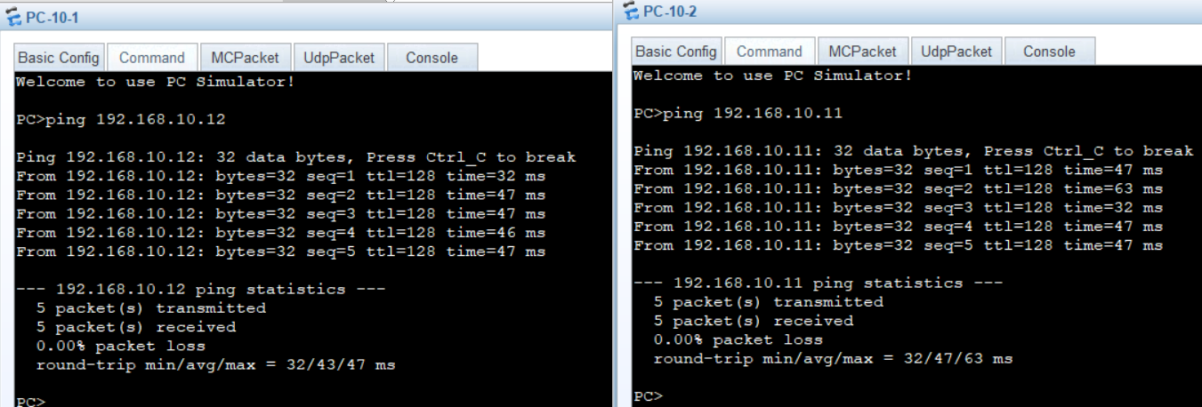
Q2-1.7. Can PCs in different VLANs ping each other? Please paste the screenshot of the ping result. If the ping fails, please explain the reasons.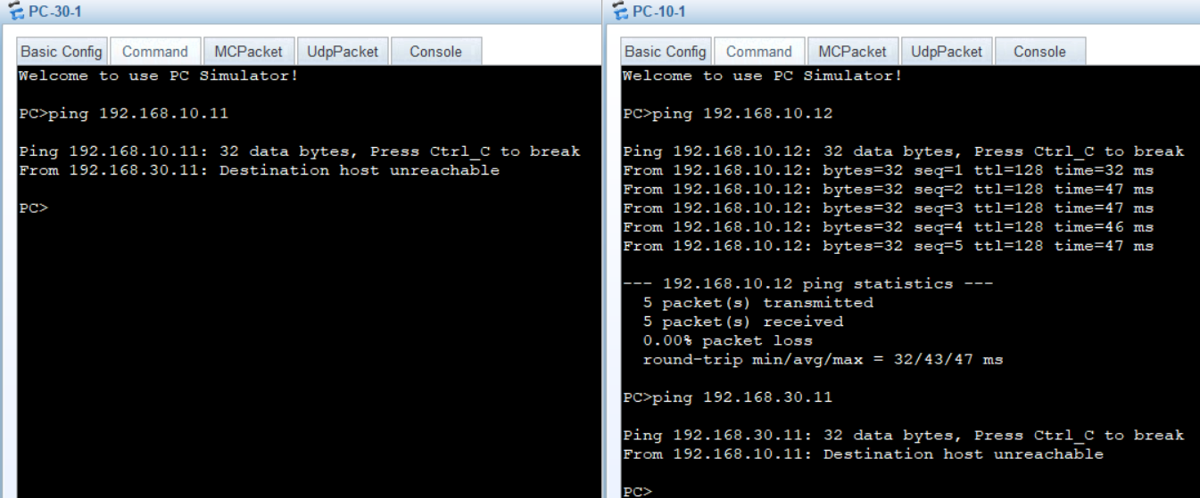
Q2-2.1. Paste the screenshot of the created topology.
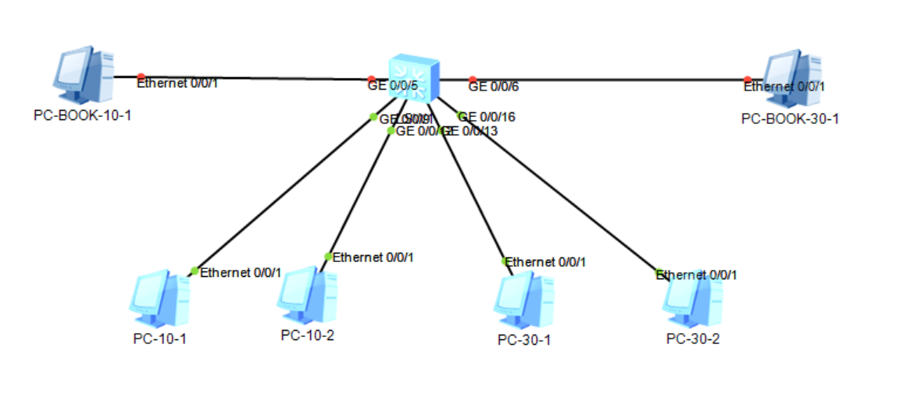
Q2-2.2. Paste the table of MAC addresses of the two laptops you recorded.
Table 2-6 MAC addresses of the two laptops
Laptop | MAC Address
PC-BOOK-10-1 | 5489-984D-2A89
PC-BOOK-30-1 | 5489-98FD-114D

Q2-2.3. Paste the screenshot of the configuration information of all MAC address-based VLANs.

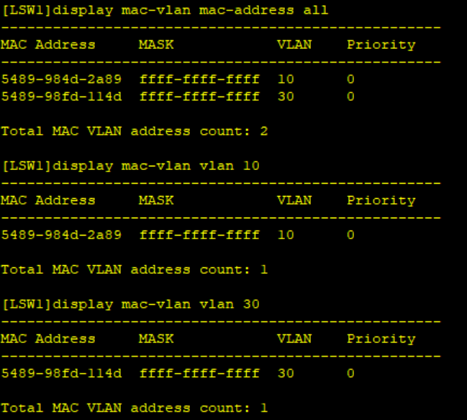

Q2-2.4. When adding members to VLAN 10 and VLAN 30 based on the MAC address, what is the difference between VLAN 10 and VLAN 30 information before and after adding members? Please paste the screenshot of VLAN 10 information before and after adding members.

Before:
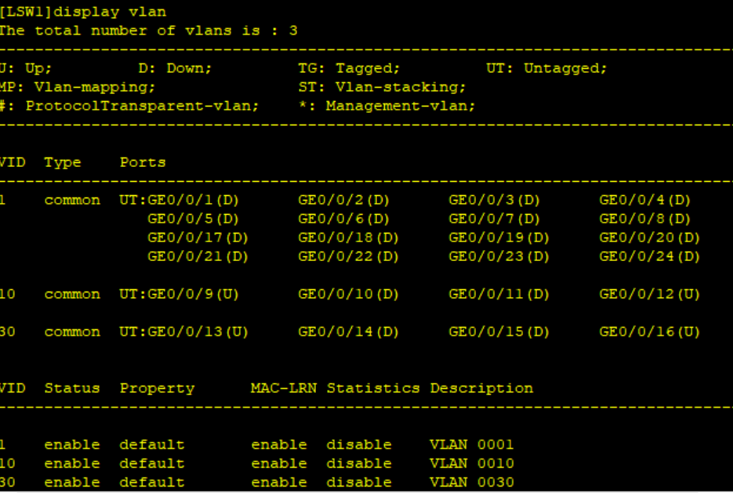
After:
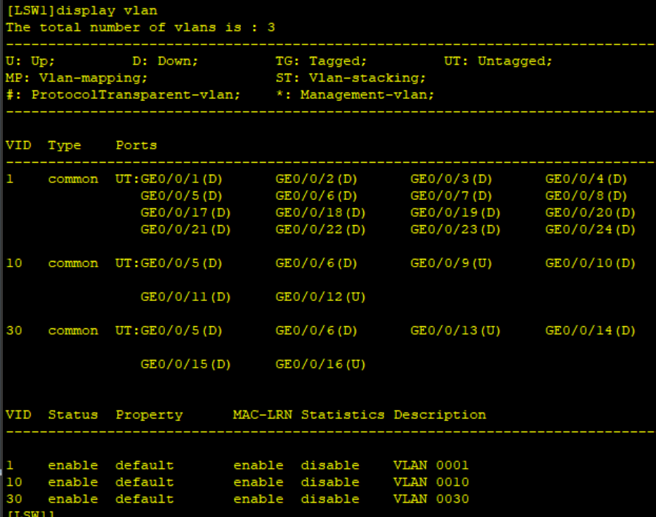
Q2-2.5. Can PC-10-1 ping PC-BOOK10-1 each other? Please paste the screenshot of the ping result.
YES
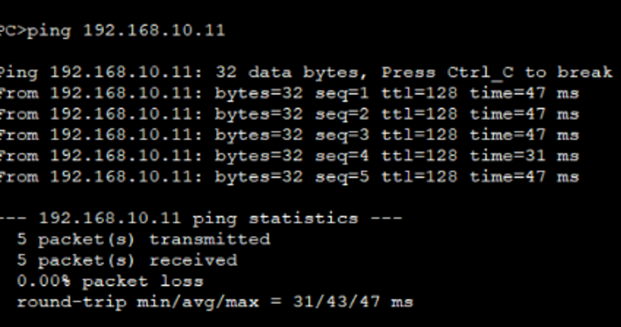
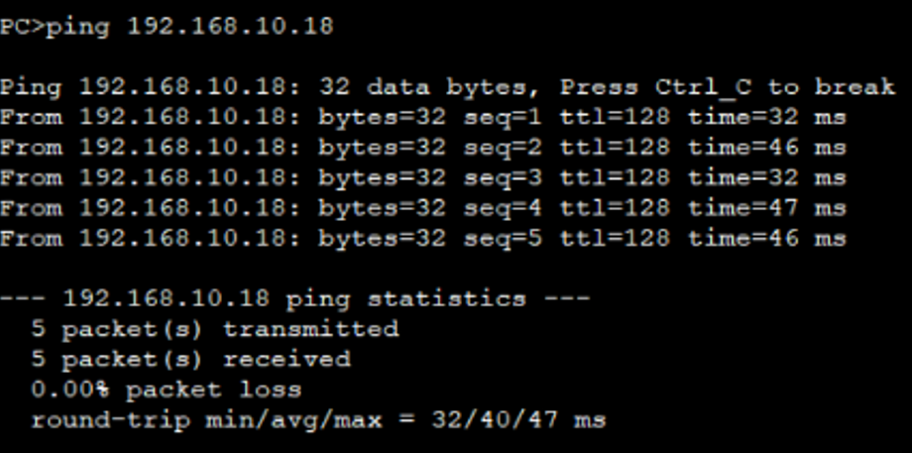

Q2-2.6. Can PC-30-1 ping PC-BOOK30-1 each other? Please paste the screenshot of the ping result.

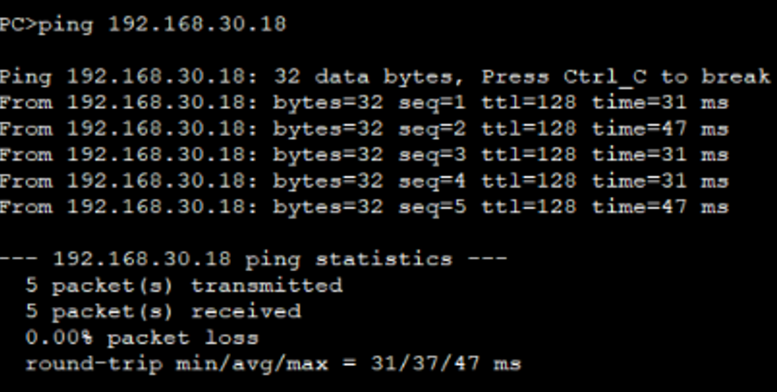
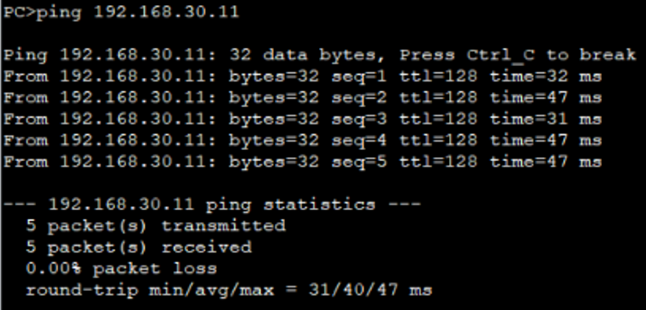

Q2-2.7. Paste the screenshot of the new topology.
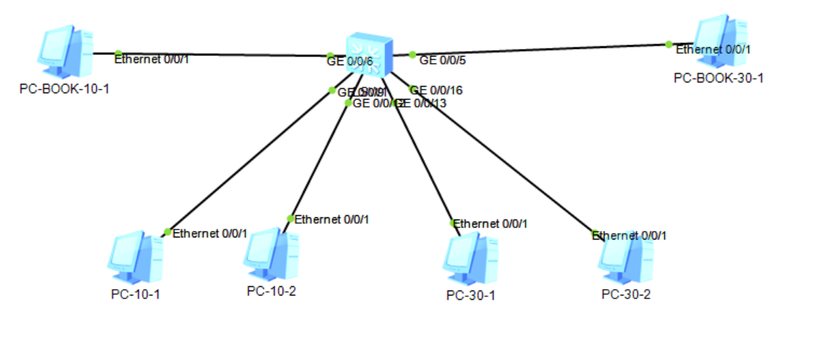
Q2-2.8. Can PC-10-1 ping PC-BOOK10-1 each other? Please paste the screenshot of the ping result.
YES
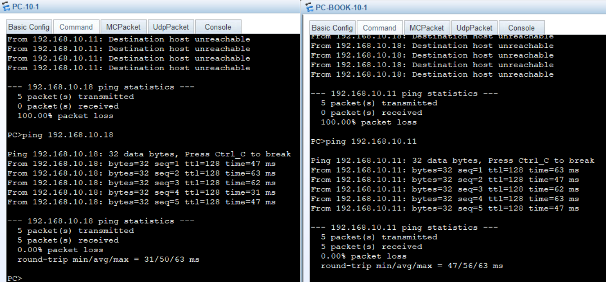

Q2-2.9. Can PC-30-1 ping PC-BOOK30-1 each other? Please paste the screenshot of the ping result.
YES
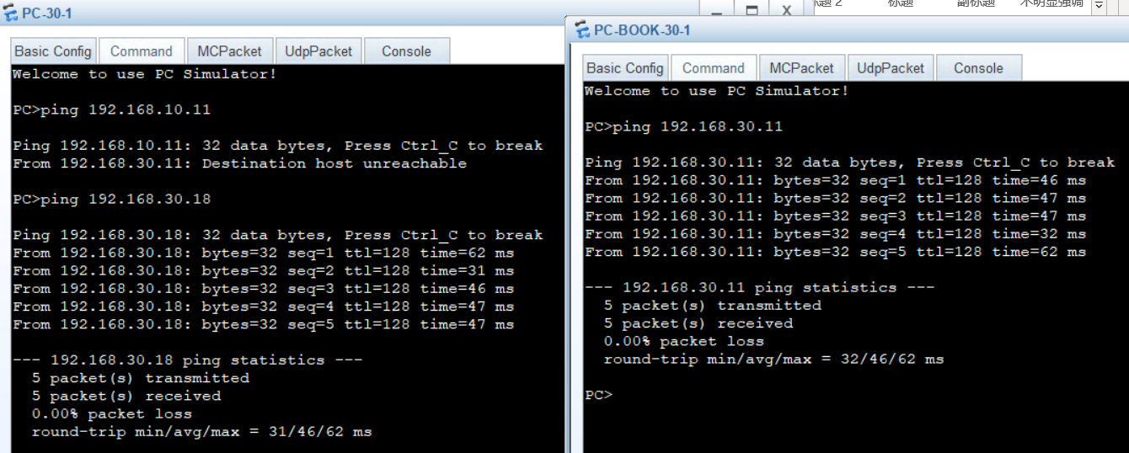

Q2-3.1. Paste the screenshot of the created topology.
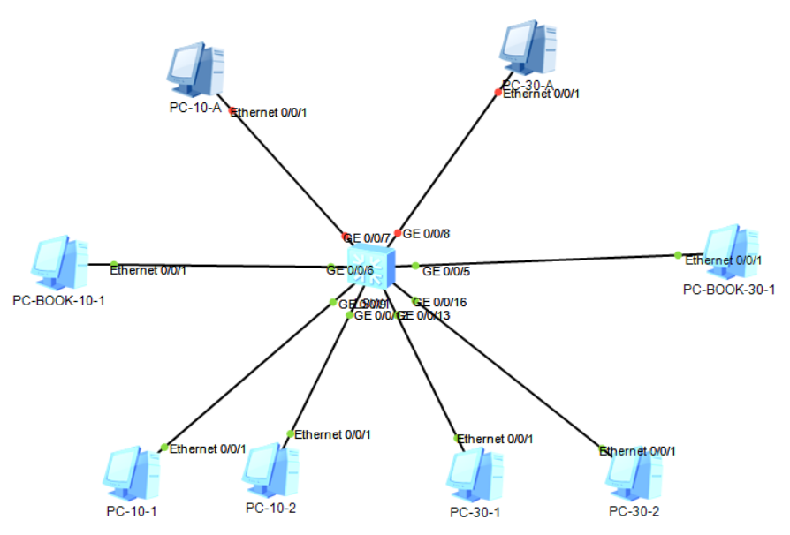
Q2-3.2. Paste the screenshot of the configuration information of all IP subnet-based VLANs
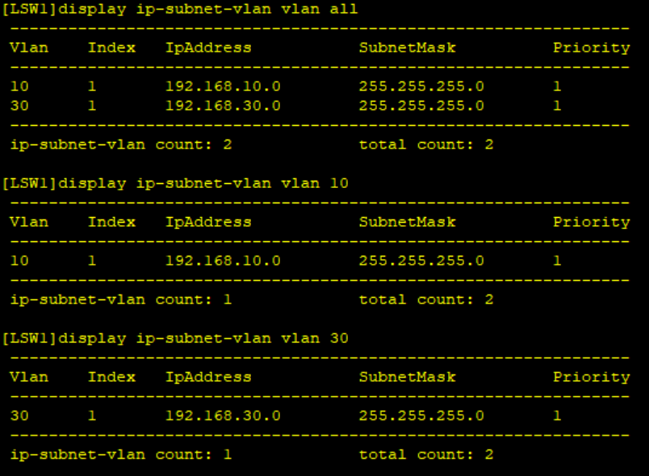
Q2-3.3. Can PC-10-1, PC-BOOK10-1 and PC-10-A ping each other? Please paste the screenshot of the ping result.
YES
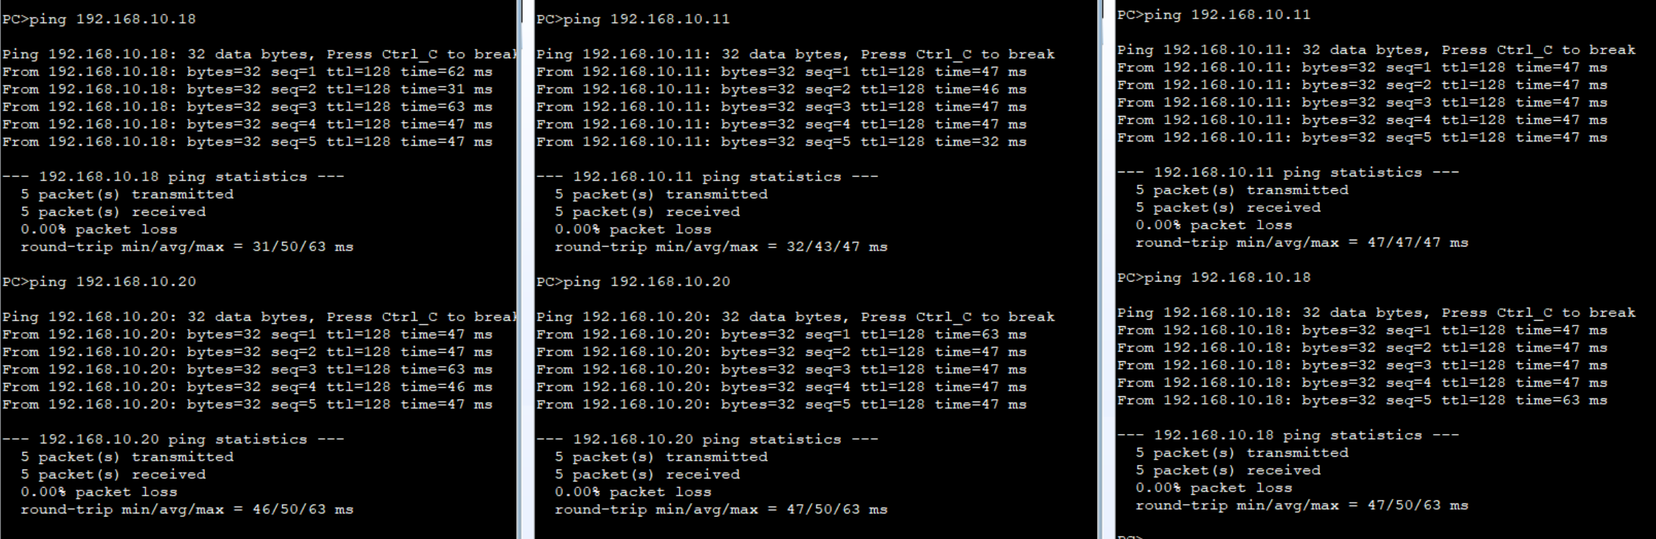

Q2-3.4. Can PC-30-1, PC-BOOK30-1 and PC-30-A ping each other? Please paste the screenshot of the ping result.
YES
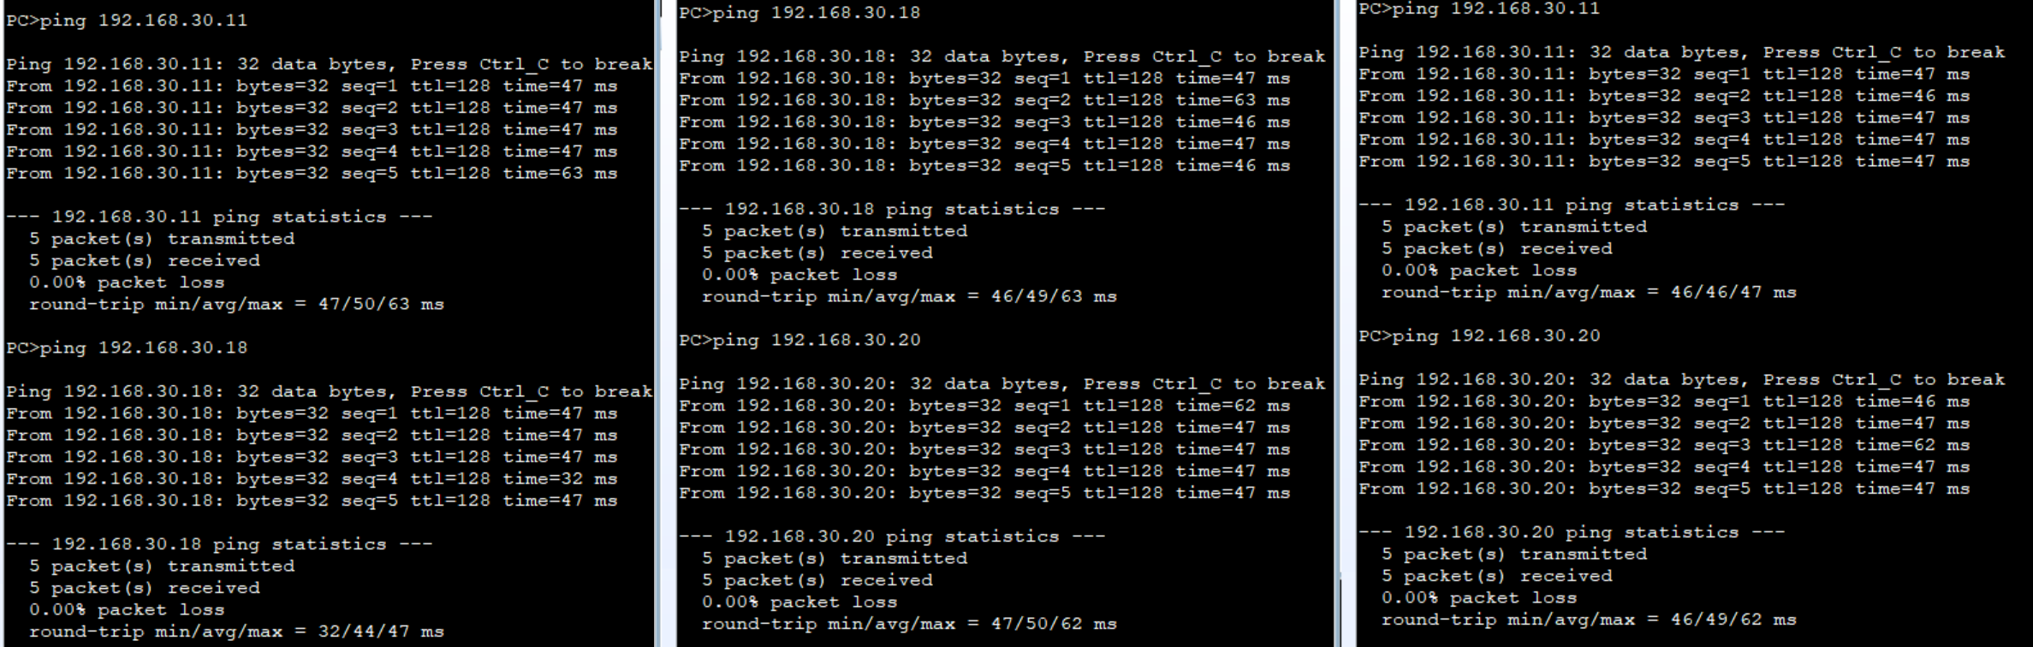

Q2-3.5. Can PC-10-1, PC-BOOK10-1 and PC-30-A ping each other? Please paste the screenshot of the ping result.
YES
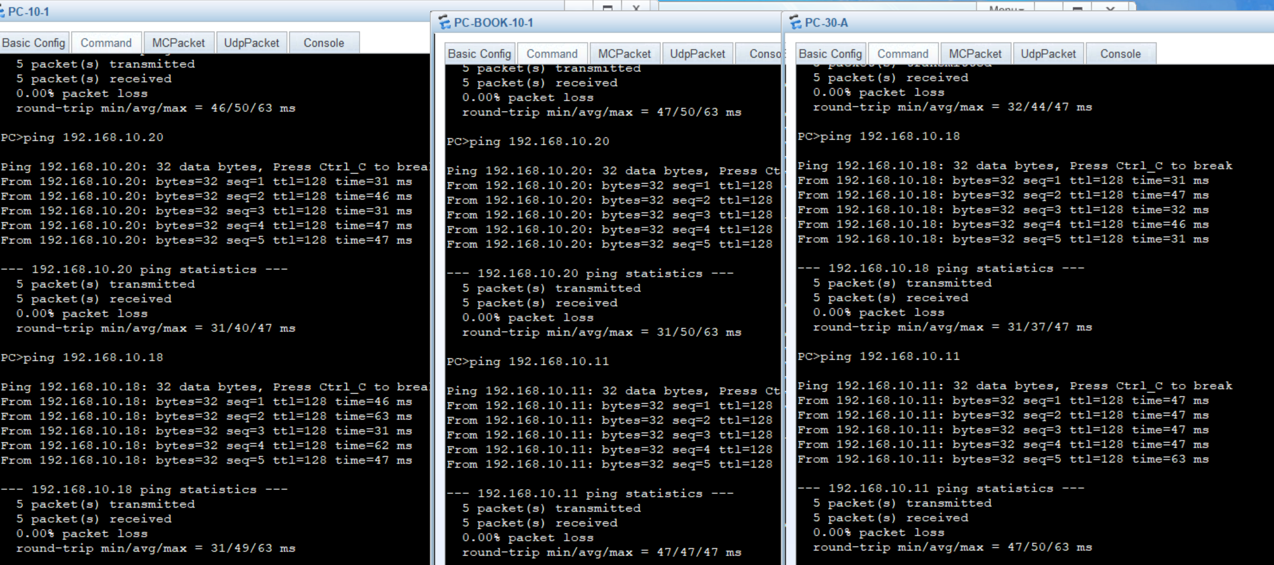
Q2-3.6. Can PC-30-1, PC-BOOK30-1 and PC-10-A ping each other? Please paste the screenshot of the ping result.\
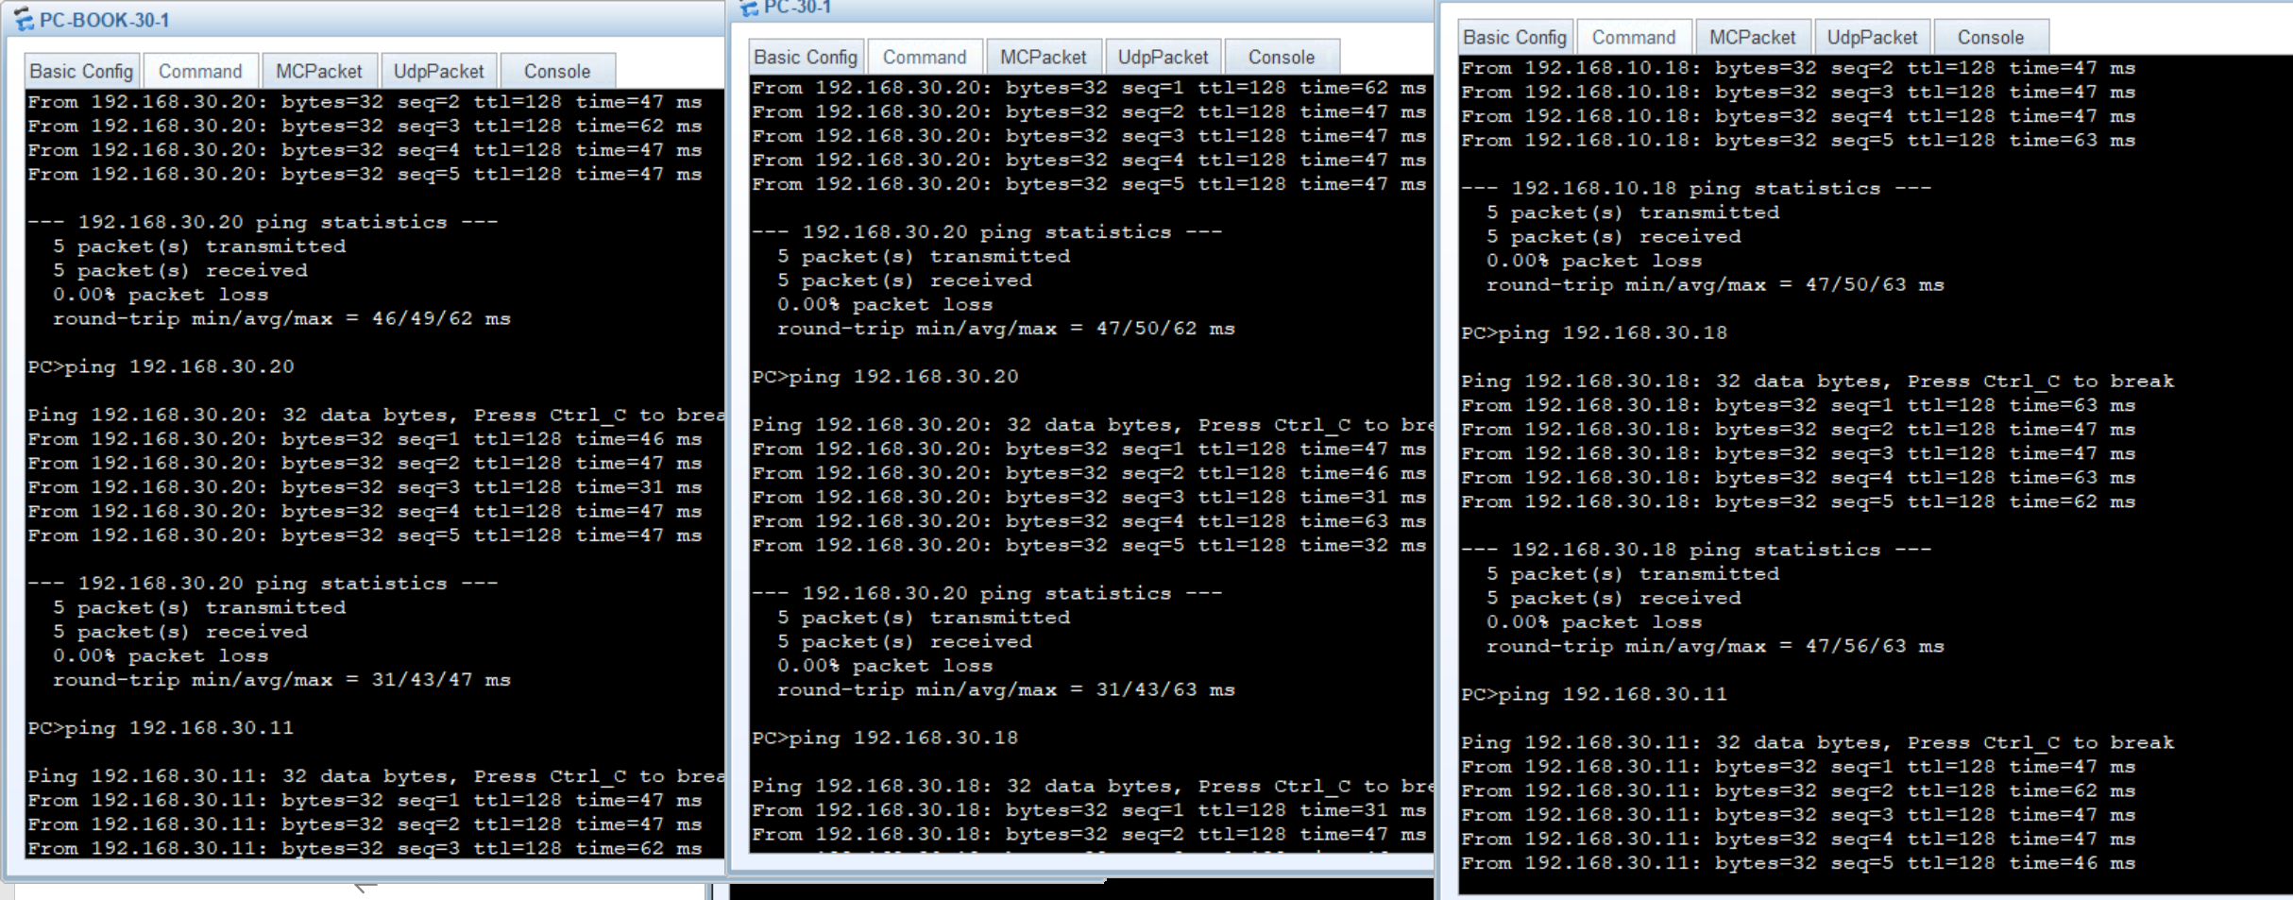
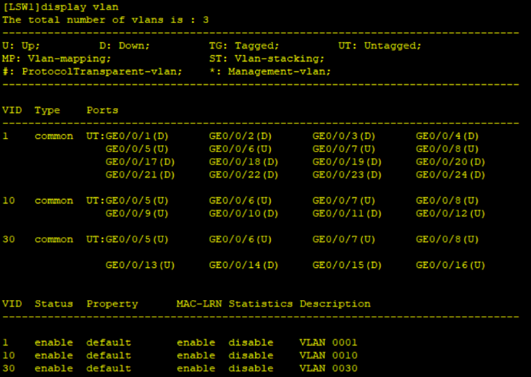
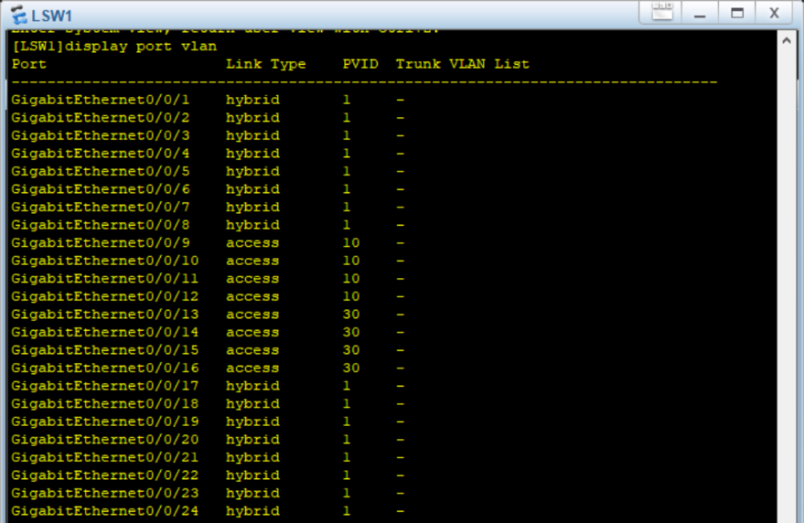
Q2-3.7. Paste information about ports or interfaces that belong to each VLAN.

Q2-4.1. Paste the screenshot of the created topology.
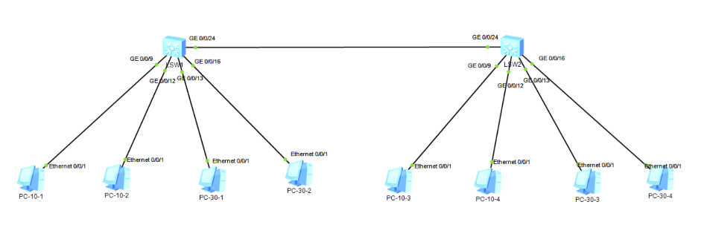
Q2-4.2. Can PC-10-1 and PC-10-3 ping each other? Please paste the screenshot of the ping result.

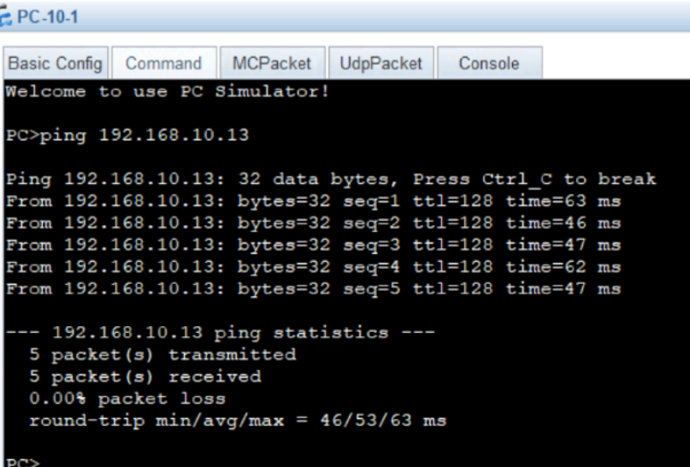

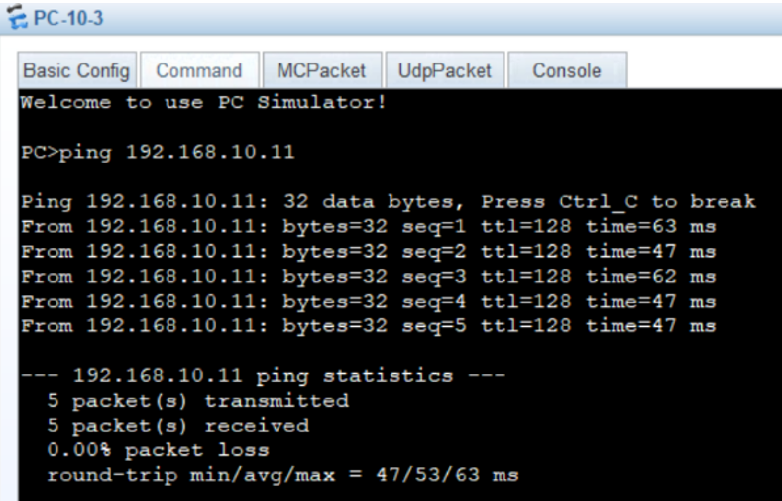
Q2-4.3. Can PC-30-1 and PC-30-3 ping each other? Please paste the screenshot of the ping result.
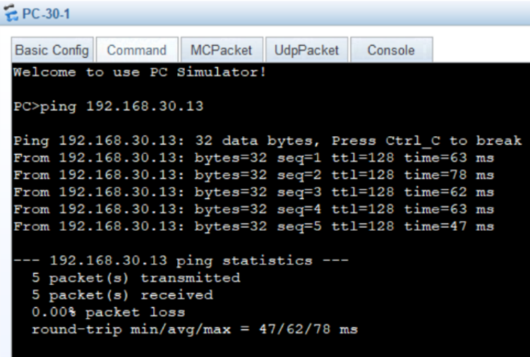
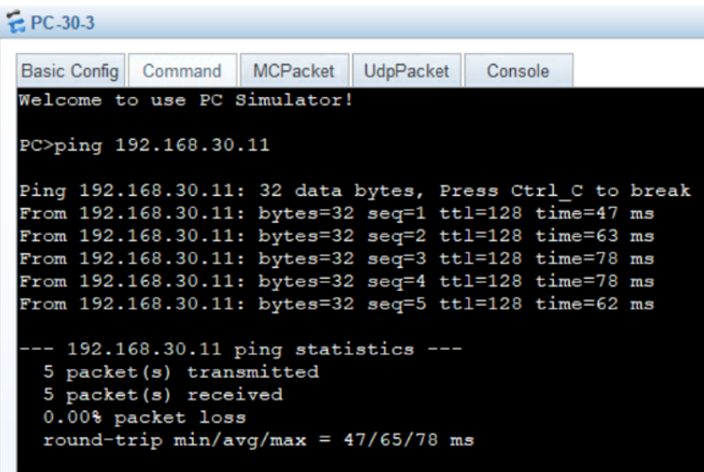

Q2-4.4. Can PC-10-1 and PC-30-3 ping each other? Please paste the screenshot of the ping result.
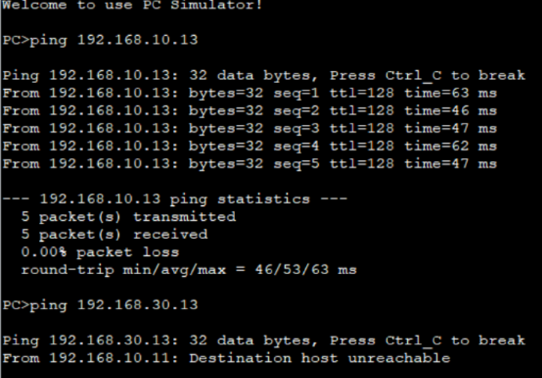
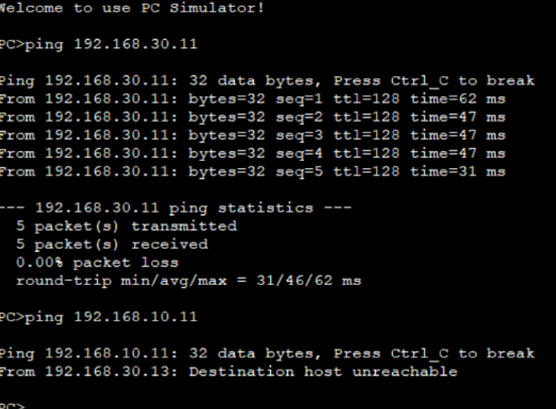

Q2-4.5. Are the Ethernet frames captured on interface GE 0/0/24 on switch LSW1 tagged or untagged frames? If they are tagged frames, what are the VLAN IDs? Please paste the screenshot of all field information of two captured Ethernet frames with different VLAN IDs.

Q2-4.6. Are the Ethernet frames captured on interface GE 0/0/9 on switch LSW1 tagged or untagged frames? If they are tagged frames, what are the VLAN IDs? Please paste the screenshot of all field information of a captured Ethernet frame.

